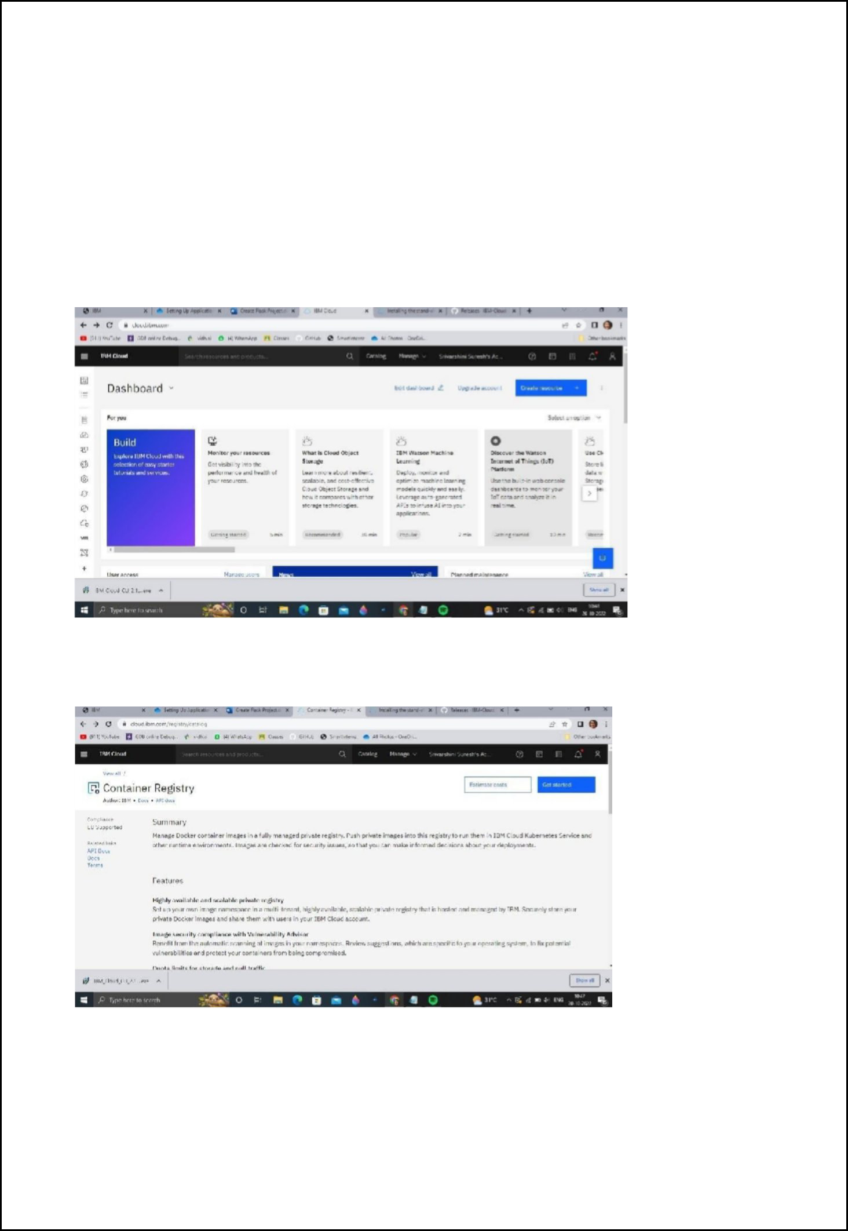
Plasma Donor Application Team ID: PNT2022TMID04418

Setting up Application Environment

Install IBM Cloud CLI

Step 1. Navigate to cloud.ibm.com

Step 2. Search on Container Registry and give get started and follow the steps to install IBM Cloud CLI

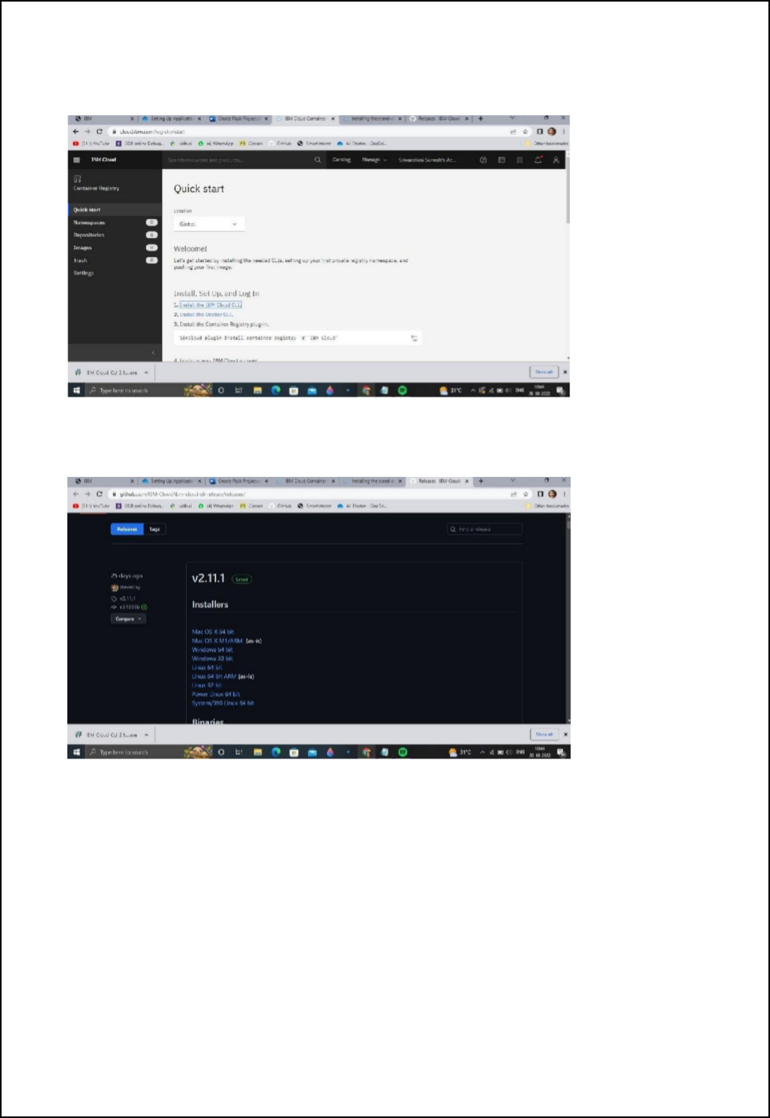
Plasma Donor Application Team ID: PNT2022TMID04418

Step 3.Download windows 64 bit installer

Step 4. Open the downloaded .exe file and run it to install IBM Cloud CLI

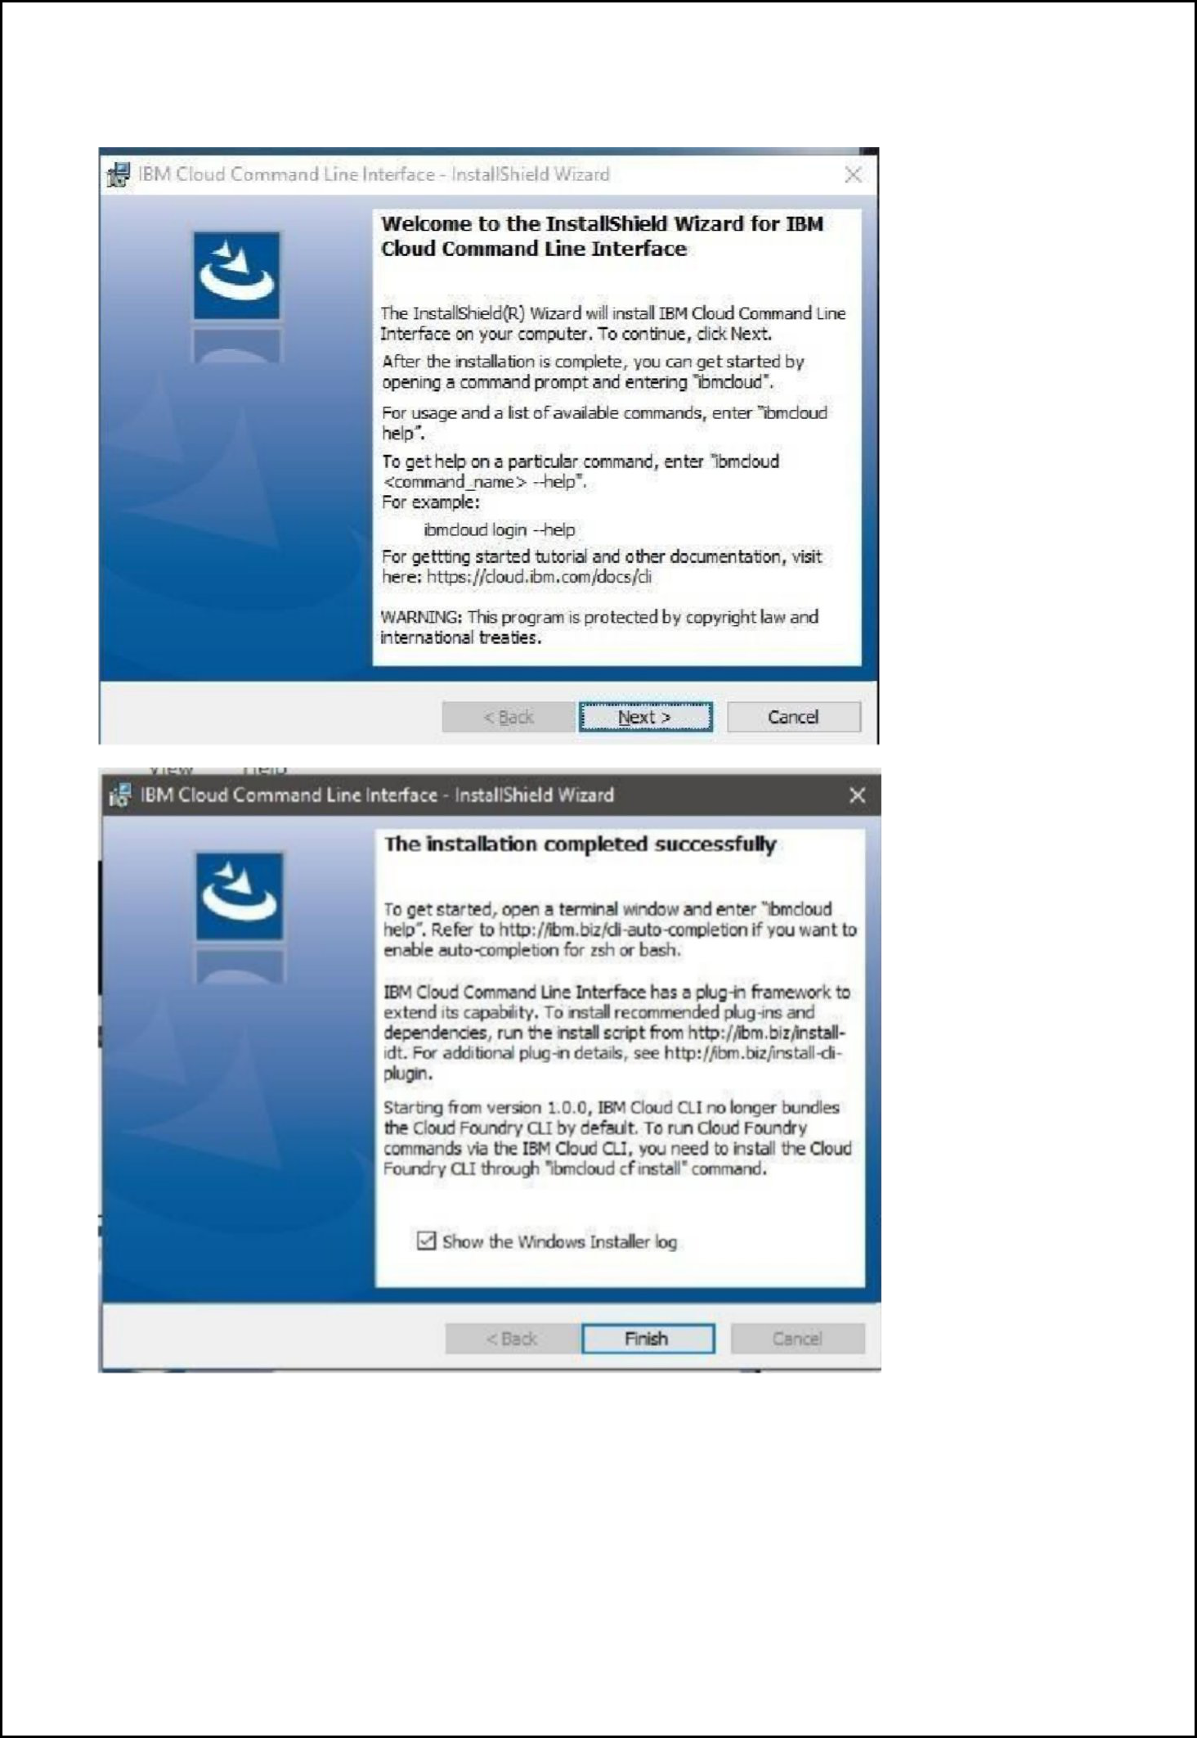
Plasma Donor Application Team ID: PNT2022TMID04418

Plasma Donor Application Team ID: PNT2022TMID04418

OUTPUT:

IBM Cloud CLI is installed successfully

